

LUTON HOO, BEDFORDSHIRE
ALUMASC EXTERIOR BUILDING PRODUCTS LIMITED

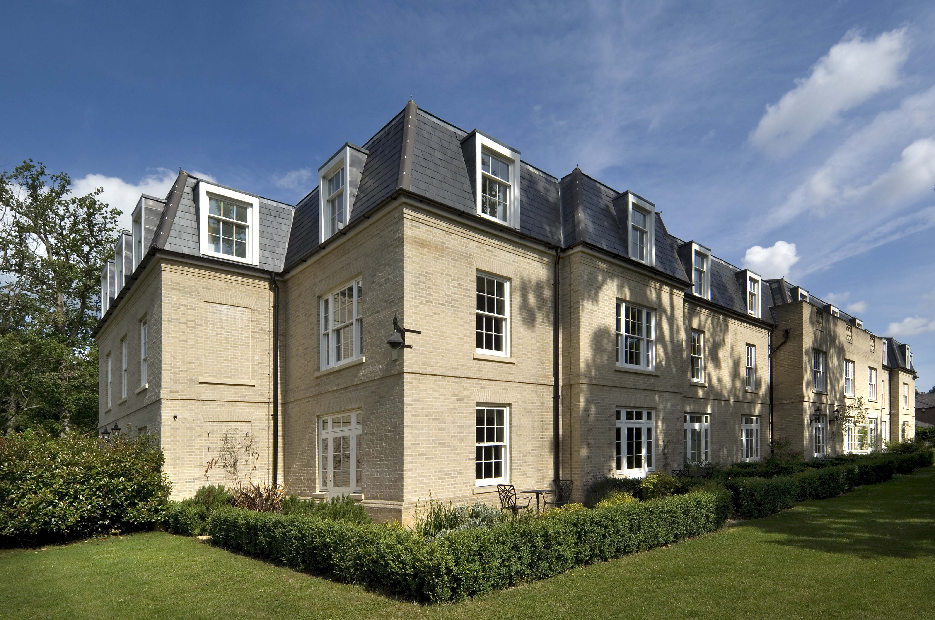

Alumasc’s Heritage cast aluminium rainwater system has provided a high performance solution for Luton Hoo in Bedfordshire – an eighteenth century mansion now in use as a five star hotel, golf and spa.

The original Grade I listed Mansion House at Luton Hoo was designed by Robert Adam, with gardens created by Capability Brown. The estate was acquired by the Elite Hotels Group in 1999 and underwent an extensive restoration and refurbishment programme to create the present-day luxury hotel.

Alumasc Heritage aluminium 125 mm half-round gutter profiles and 102mm downpipes have been used on the most recent phase. This work involved the refurbishment and construction of a number of buildings including the Parkland Wing, the Garden Wing and Stables conversion.

Clague Architects specified the Heritage system as it was in keeping with both the new and refurbished areas which have been designed to carefully respect the setting of the historic estate. It was also important that Alumasc was able to offer technical and on-site support throughout the installation.

The Heritage range is ideal for traditionally designed buildings and can be used as a direct replacement of cast iron while offering all the benefits of modern aluminium casting techniques and factory finish. The system has minimal maintenance requirements and is lightweight, durable and easy to handle and fix.

The half-round profile in PPC black chosen for Luton Hoo is one of five profiles that are available in the range, alongside a choice of imperial sizes and RAL colours to suit all projects.

Heritage cast aluminium is also available ex-stock with the popular textured black PPC finish, in half round 4”, 4½” and 5” profiles and circular pipe in 2½” and 3” diameters, offering an unrivalled lead time of 3 days. Alumasc is the only manufacturer to supply its aluminium rainwater systems accredited with BBA approved powder coatings.



www.alumascrainwater.co.uk

©2013 MGMA - 106 Ruskin Avenue, Rogerstone, Newport, South Wales NP10 0BD Tel: 01633 891584
mgmagutters@gmail.com www.mgma.co.uk

